**(1) Define VGG16 model :**

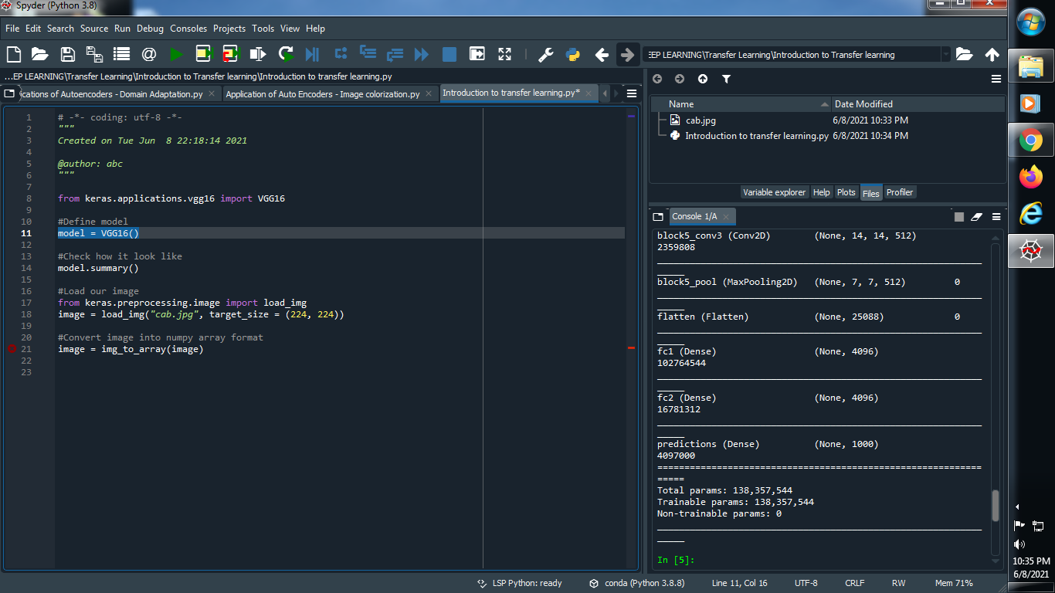

**(2) Check the model how it looks like :**

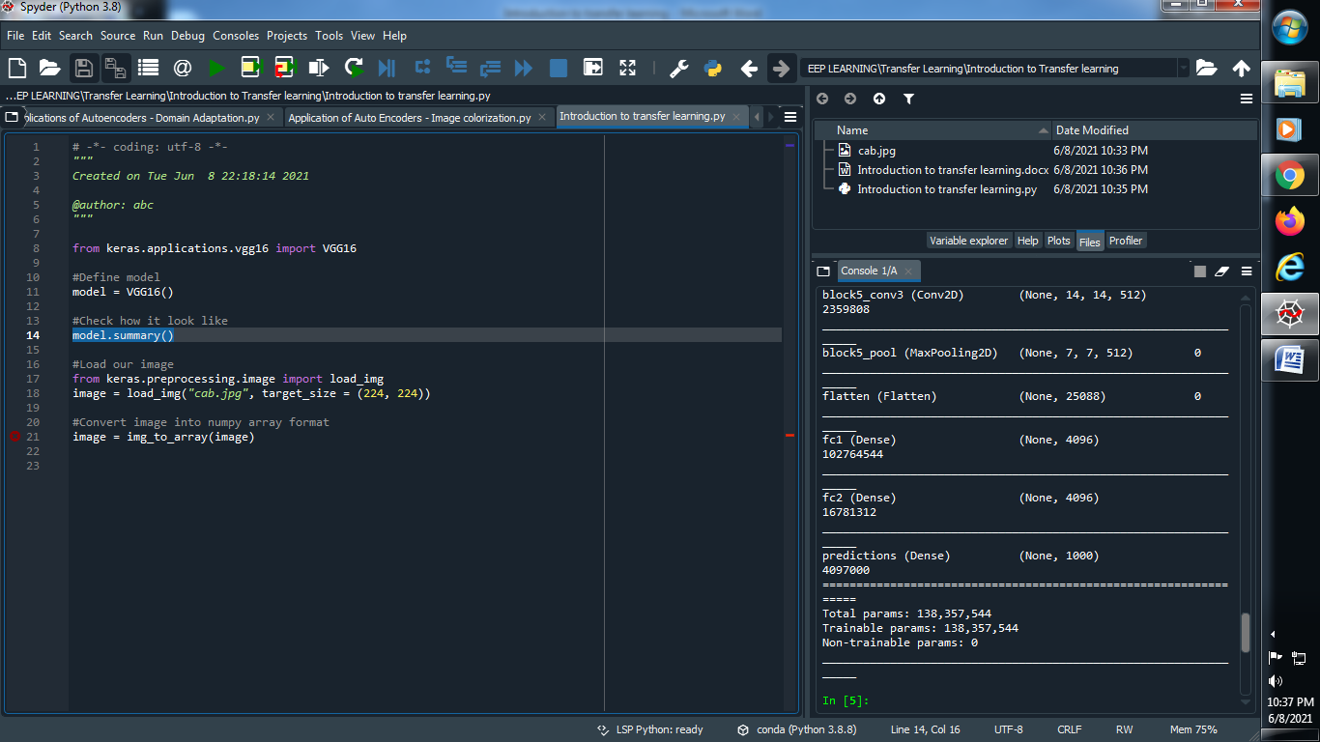

**Output :**

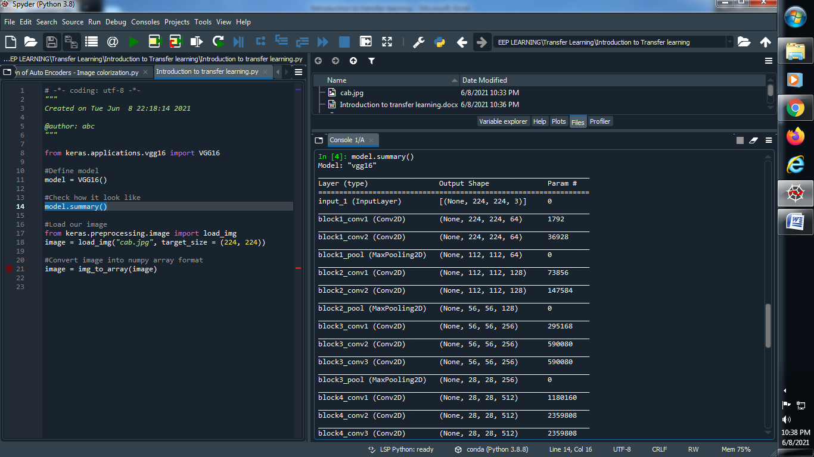

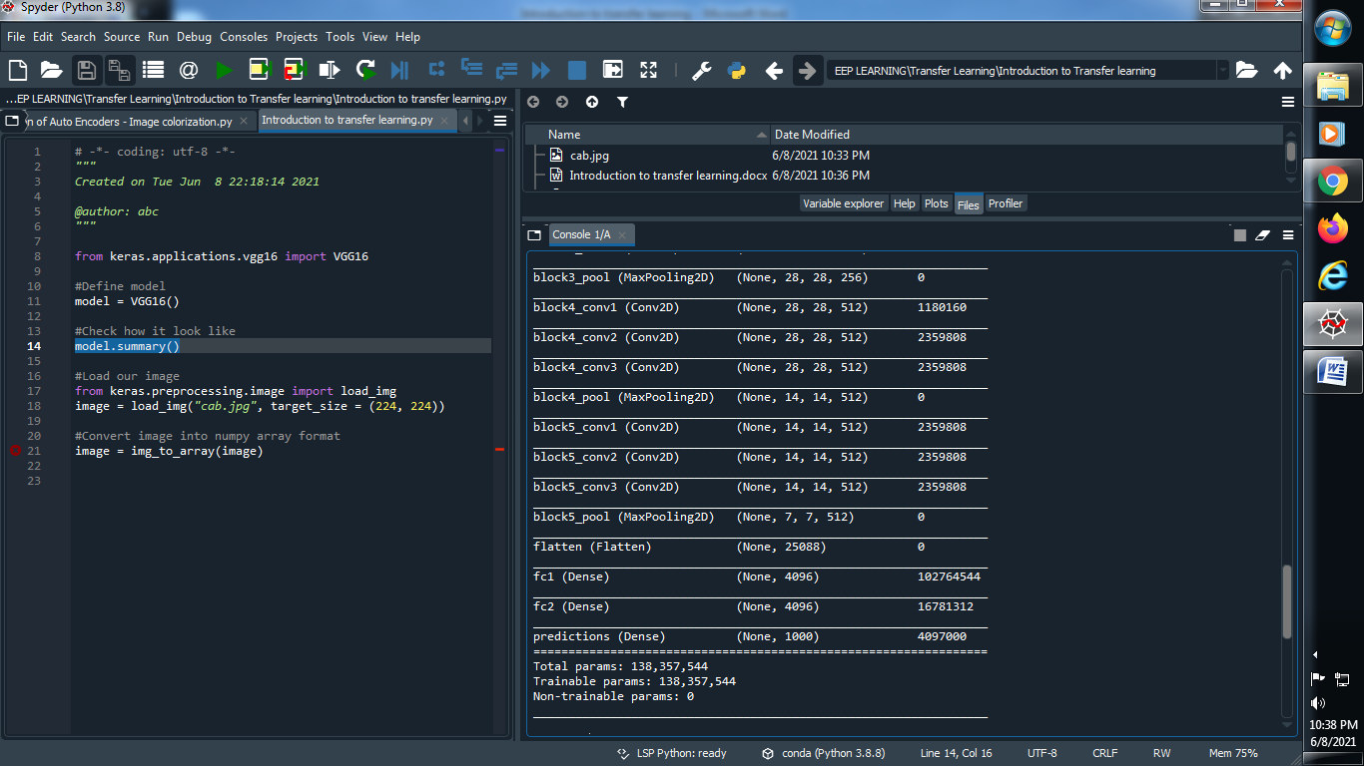

**(3) Read and load our image :**

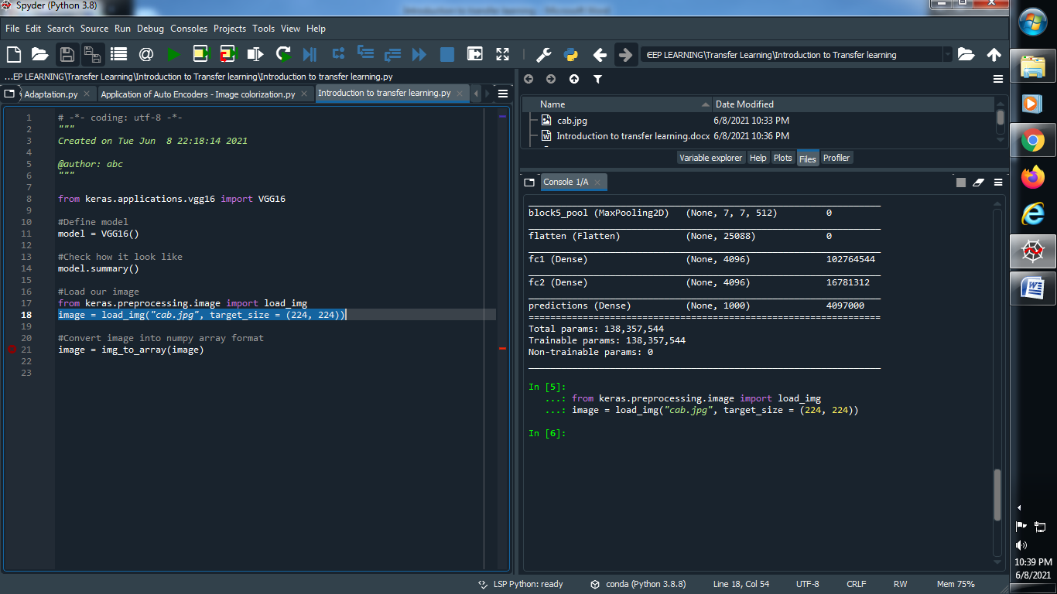

**Output :**

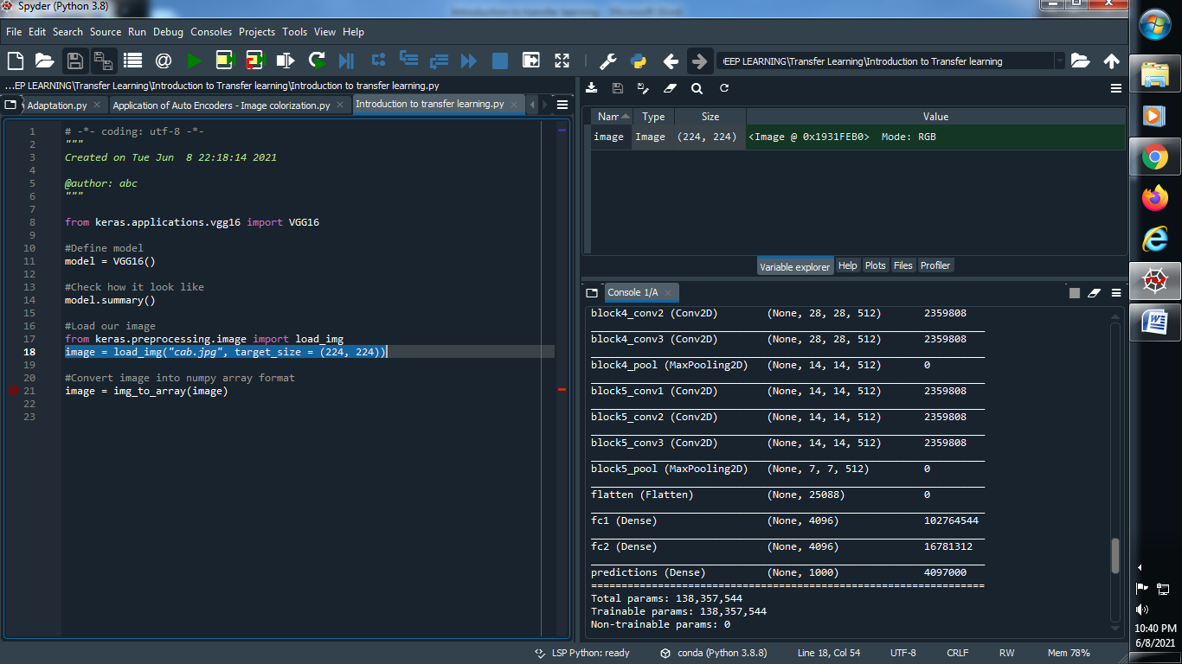

**(4) Convert image into numpy array format :**

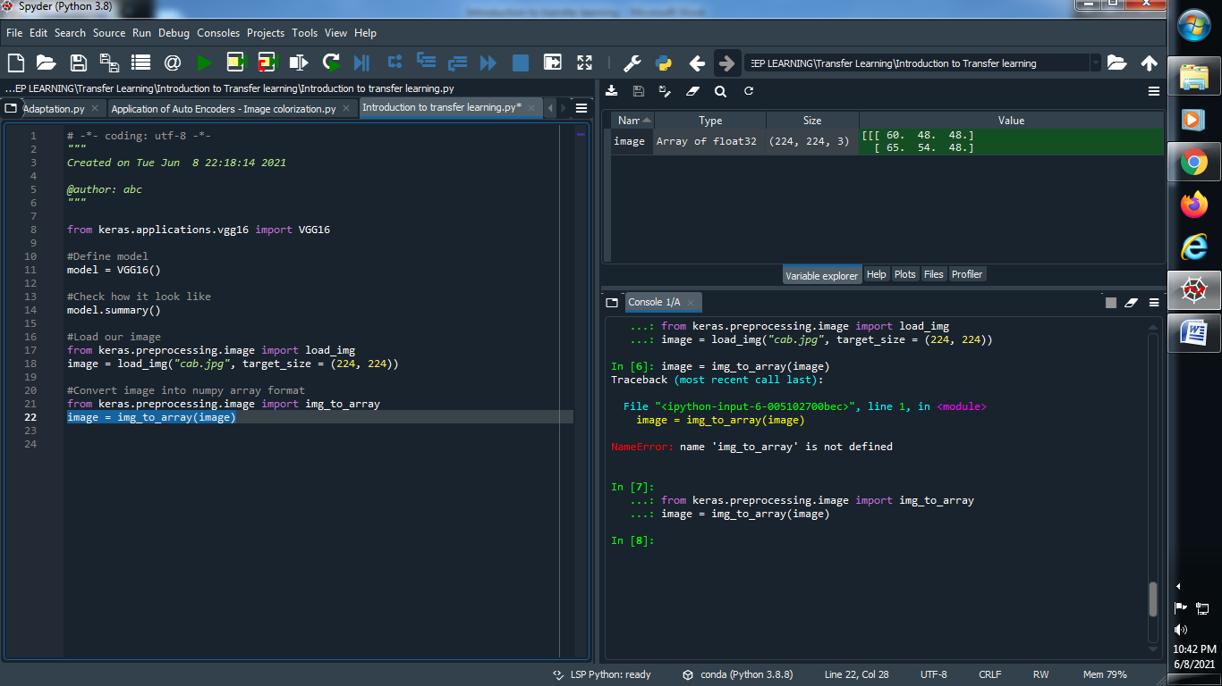

**Output :**



**(5) Give the shape to our array :**

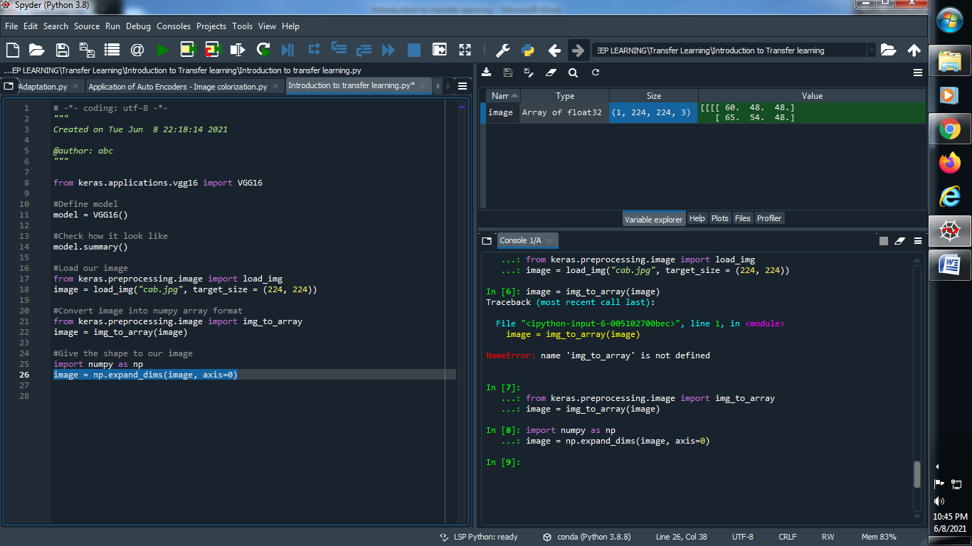

**Output :**



**(6) To get better results we need preprocess our results :**

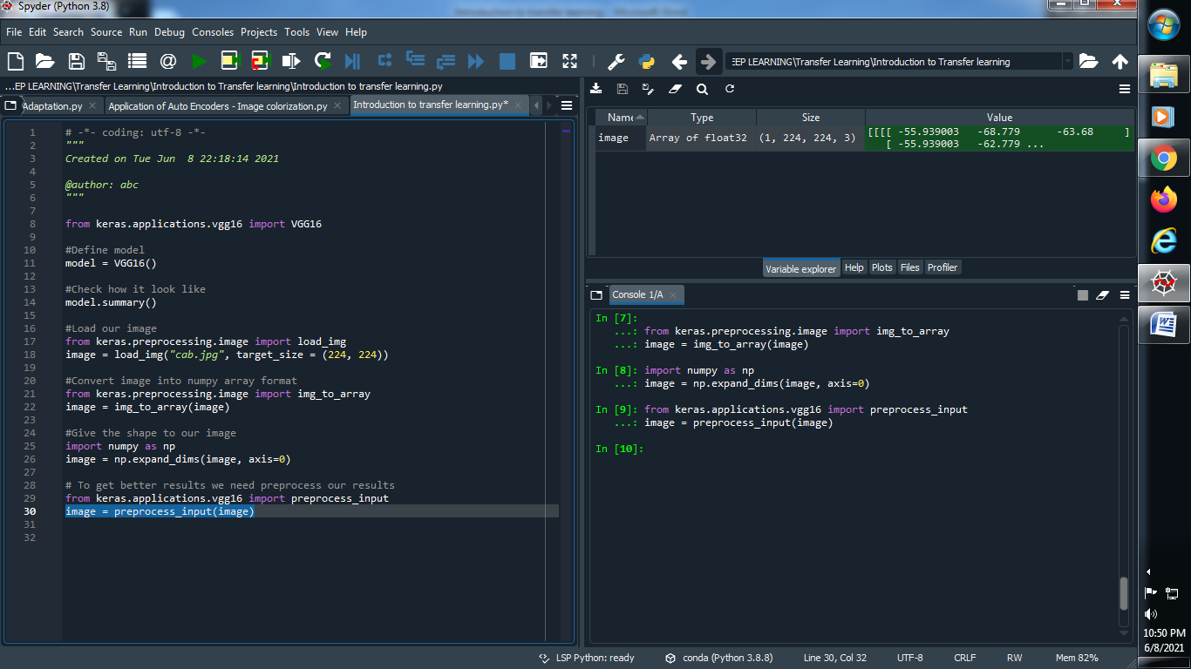

**Output :**



**(7) Predict our model :**

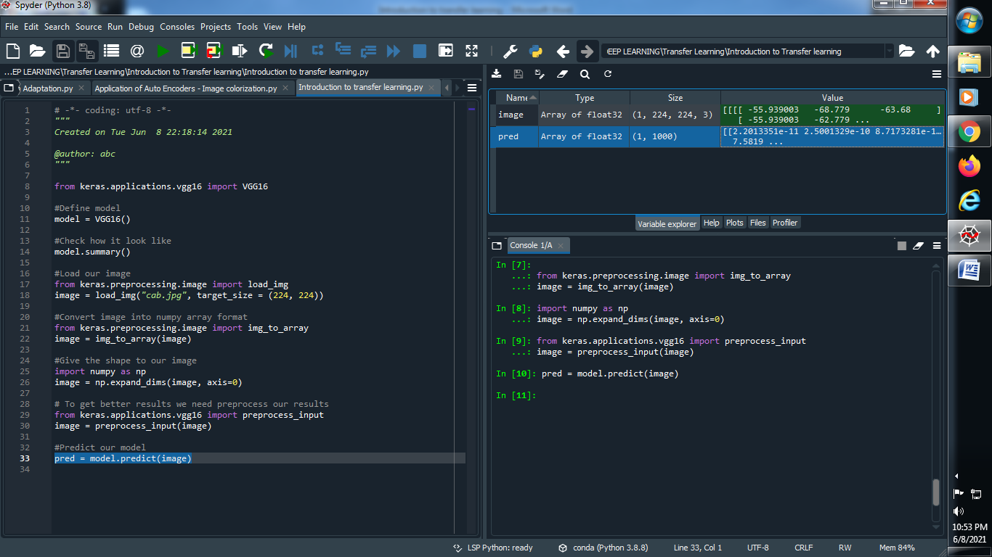

**Output :**



**(8) Print our predictions :**

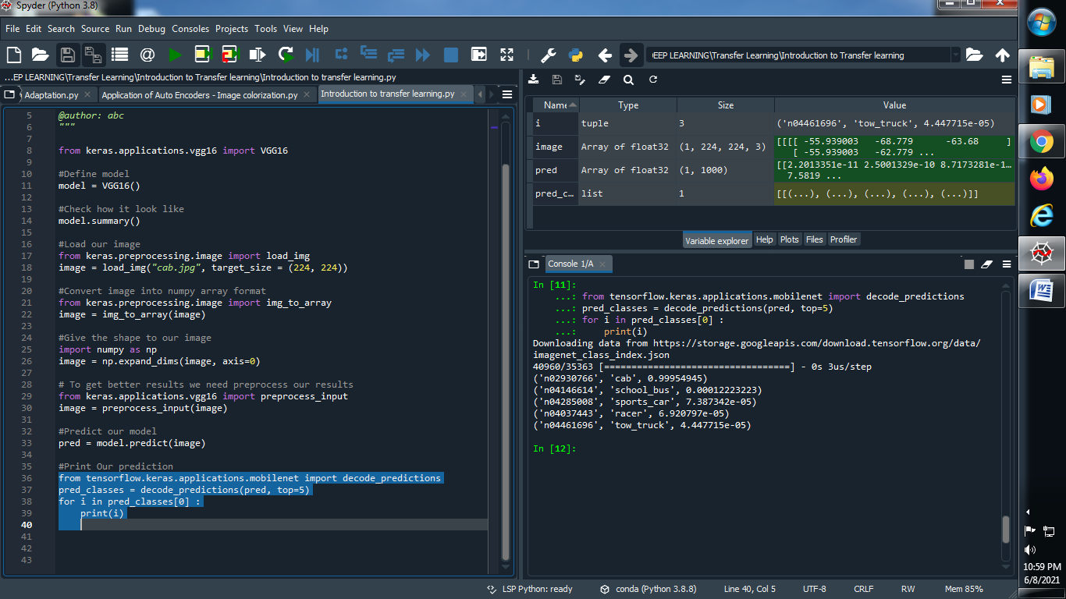

**→ Original image :**

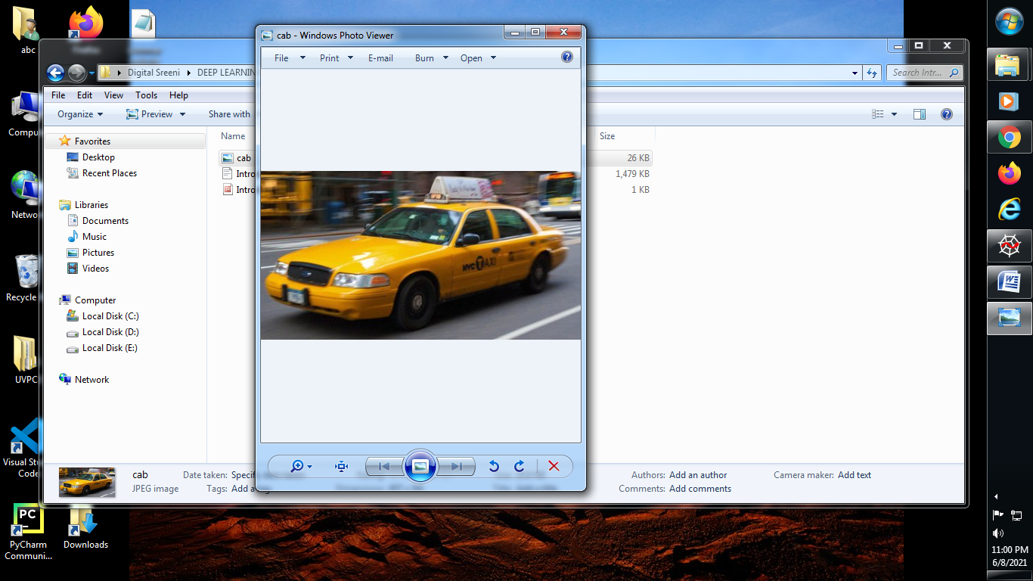

**→ Output :**

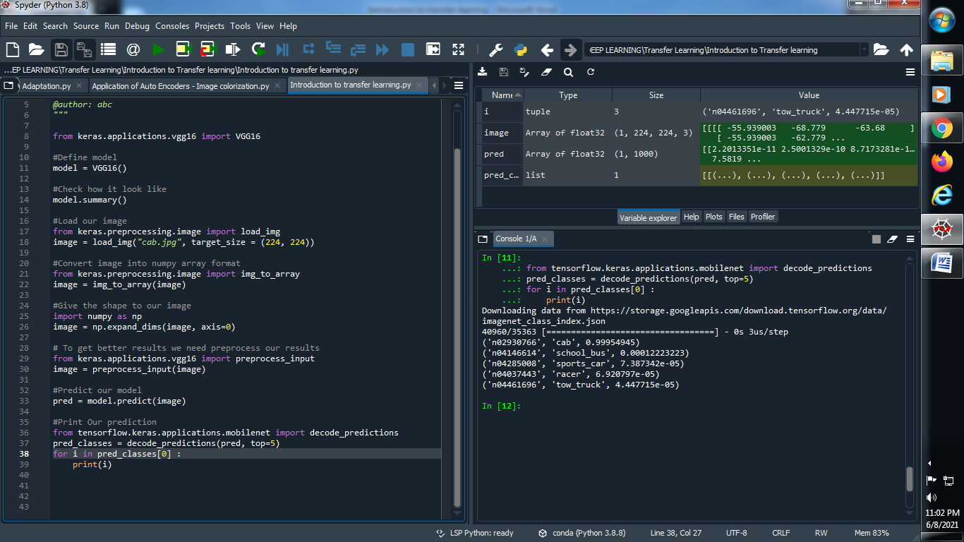

**(9) Let’s perform it on another image :**

**→ Original image : → Code :**

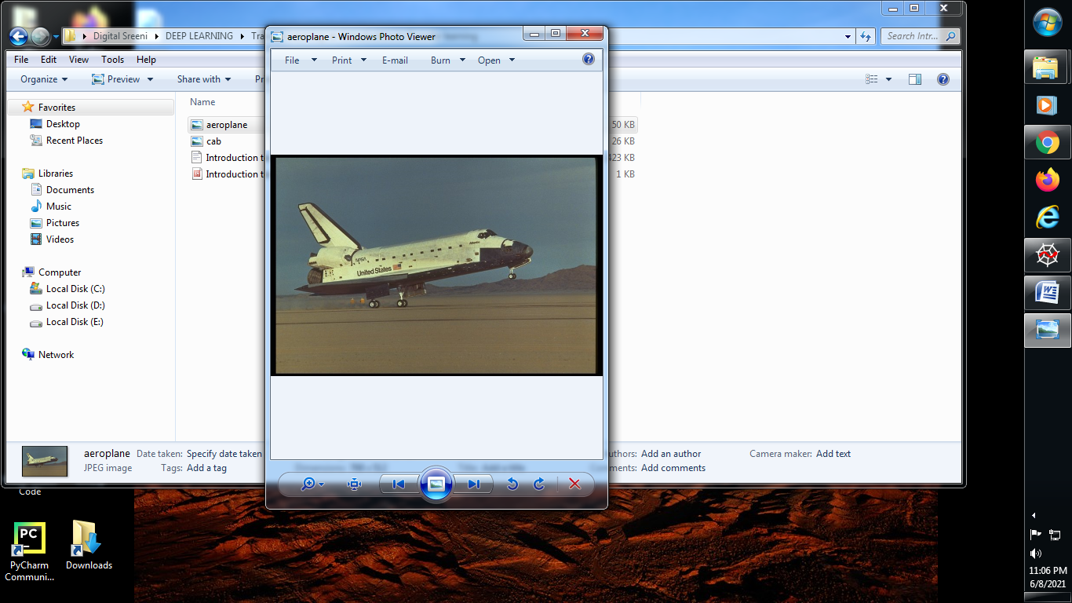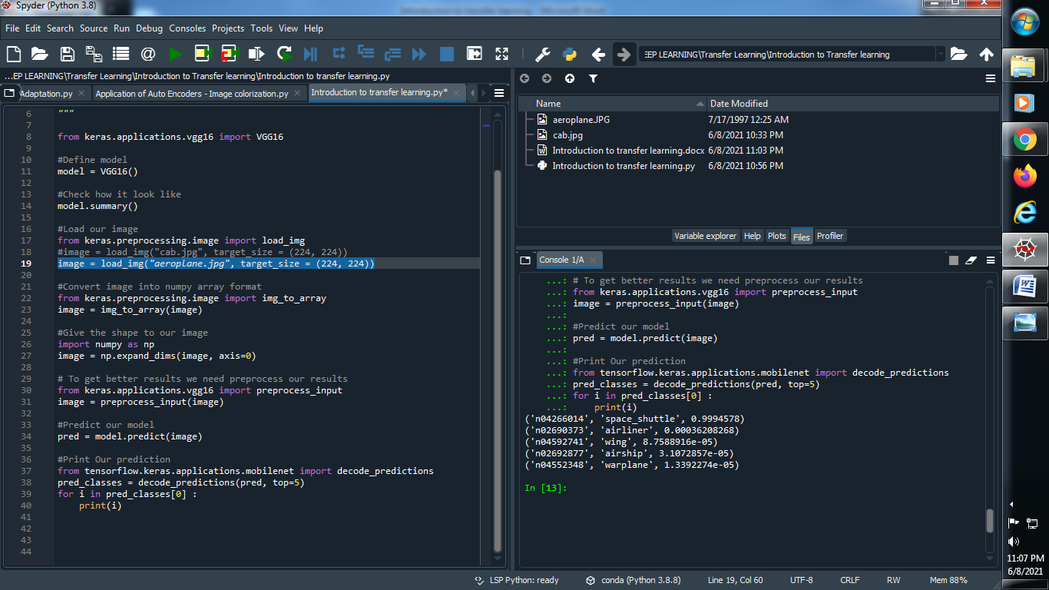

**Output :**

